**EMPOWERING RURAL ARTISANS FOR SUSTAINABLE DEVELOPMENT USING PR ALGORITHM**

## A PROJECT REPORT

***Submitted by***

**SWEATHA R (2116210701275)**

**THAMIZH BHARATHI M (2116210701288)**

**THIRU ESHWARAN V (2116210701290)**

***in partial fulfillment for the award of the degree of***

**BACHELOR OF ENGINEERING**

***in***

## COMPUTER SCIENCE AND ENGINEERING



**RAJALAKSHMI ENGINEERING COLLEGE ANNA UNIVERSITY, CHENNAI**

**MAY 2024**

# RAJALAKSHMI ENGINEERING COLLEGE, CHENNAI

**BONAFIDE CERTIFICATE**

Certified that this Thesis titled **“EMPOWERING RURAL ARTISANS FOR SUSTAINABLE DEVELOPMENT USING PR ALGORITHM**” is the bonafide work of “**SWEATHA R (2116210701275), THAMIZH BHARATHI M (2116210701288), THIRU ESHWARAN V(2116210701290)**” who carried out the work under my supervision. Certified further that to the best of my knowledge the work reported herein does not form part of any other thesis or dissertation on the basis of which a degree or award was conferred on an earlier occasion on this or any other candidate.

## SIGNATURE

**Dr . P.SHANMUGAM M.Tech., Ph.D,**

## PROJECT COORDINATOR

Associate Professor

Department of Computer Science and Engineering Rajalakshmi Engineering College

Chennai - 602 105

Submitted to Project Viva-Voce Examination held on

**Internal Examiner External Examine**r

# ABSTRACT

# In the era of technological advancement, our proposed model introduces an innovative AI-powered application to empower the traditional crafts industry. The primary aim is to promote traditional products, support rural artisans, and safeguard cultural heritage. This platform bridges the gap between skilled artisans and the modern consumer. The project promotes the development of an intuitive application that empowers rural artisans by providing them with a direct channel to showcase their craftsmanship to a global audience. One of the key innovations of this platform lies in its elimination of intermediary vendors, thereby enhancing the overall quality of traditional products while offering substantial cost savings to consumers. Our platform is the integration of a sophisticated PR (Product Recommendation) Algorithm, leveraging the power of machine learning. This intelligent algorithm plays a vital role in increasing sales opportunities for artisans by analyzing user preferences and behaviors. Through continuous engagement with the platform, users receive personalized recommendations tailored to their individual tastes and preferences, thereby enhancing their overall experience. Furthermore, the platform serves as a way for preserving cultural heritage by promoting traditional crafts in a modern context. By providing direct interaction between artisans and consumers, it fosters a deeper appreciation for traditional craftsmanship while simultaneously providing rural artisans with an expanded market reach. Our model merges tradition and technology to revive the traditional crafts industry and empower rural artisans. Using artificial intelligence, the platform aims to build a sustainable system where tradition and modernity coexist harmoniously.

# ACKNOWLEDGMENT

We thank the almighty god for the successful completion of the project. Our sincere thanks to our chairman **Mr. S. MEGANATHAN B.E., F.I.E.,** for his sincere endeavor in educating us in his premier institution. We would like to express our deep gratitude to our beloved Chairperson **Dr. (Mrs.) THANGAM MEGANATHAN Ph.D.,** for her enthusiastic motivation which inspired us a lot in completing our model and Vice Chairman **Mr. ABHAY SHANKAR MEGANATHAN B.E., M.S.,** for providing us with the requisite infrastructure.

We also express our sincere gratitude to our college Principal,

**Dr. S. N. MURUGESAN M.E., PhD.,** and **Dr. P. KUMAR M.E., PhD, Director computing and information science , and Head Of the Department of Computer Science and Engineering** and our Project Coordinator **Dr. P. SHANMUGAM, M.Tech., Ph.D, Associate Professor,** for his encouragement and guiding us throughout the project towards successful completion of our model and to our parents, friends, all faculty members and supporting staffs for their direct and indirect involvement in successful completion of the project for their encouragement and support.

**SWEATHA R**

**THAMIZH BHARATHI M**

**THIRU ESHWARAN V**

## TABLE OF CONTENTS

|  |  |  |  |  |  |
| --- | --- | --- | --- | --- | --- |
| **CHAPTER NO** | | **TITLE** | | **PAGE NO** | |
|  | | **ABSTRACT** | | **iii** | |
|  | | **ACKNOWLEDGEMENT** | | **iv** | |
|  | | **LIST OF FIGURES** | | **vii** | |
| **1.** | | **INTRODUCTION** | | **1** | |
|  | | 1.1 PROBLEM STATEMENT | |  | |
|  | | 1.2 SCOPE OF THE WORK | |  | |
|  | | 1.3 AIM AND OBJECTIVES OF THE PROJECT | |  | |
|  | | 1.4 RESOURCES | |  | |
|  | | 1.5 MOTIVATION | |  | |
| **2.** | | **LITERATURE SURVEY** | | **5** | |
| **3.** | | **SYSTEM DESIGN** | | **12** | |
|  | | 3.1 GENERAL | |  | |
|  | | 3.2 SYSTEM ARCHITECTURE DIAGRAM | |  | |
|  | | 3.3 DEVELOPMENT ENVIRONMENT | |  | |
|  | | 3.3.1 HARDWARE REQUIREMENTS | |  | |
|  | | 3.3.2 SOFTWARE REQUIREMENTS | |  | |

|  |  |  |  |  |  |
| --- | --- | --- | --- | --- | --- |
| **4.** | | **PROJECT DESCRIPTION** | | **14** | |
|  | | 4.1 METHODOLOGY | |  | |
|  | | 4.2 MODULE DESCRIPTION | |  | |
| **5.** | | **RESULT AND DISCUSSIONS** | | **17** | |
|  | | 5.1 OUPUT | |  | |
|  | | 5.2 RESULT | |  | |
| **6.** | | **CONCLUSION AND FUTURE ENCHANCEMENT** | | **21** | |
|  | | 6.1 CONCLUSION | |  | |
|  | | 6.2 FUTURE ENHANCEMENT | |  | |
|  | | **APPENDIX** | | **22** | |
|  | | **REFERENCES** | | **25** | |

|  |  |  |
| --- | --- | --- |
|  | **LIST OF FIGURES** |  |

|  |  |  |
| --- | --- | --- |
| **FIGURE.NO** | **TITLE** | **PAGE NO** |
| 3.1 | SYSTEM ARCHITECTURE | 9 |
| 5.1 | HOME SCREEN | 14 |
| 5.2 | LIST OF PRODUCTS | 15 |
| 5.3 | CHECKOUT PAGE | 15 |
| 5.4 | CART | 16 |
| 5.5 | LOGIN PAGE | 16 |

**CHAPTER 1**

## INTRODUCTION

In the era of technological advancement, our proposed model introduces an innovative AI-powered application to empower the traditional crafts industry. The primary aim is to promote traditional products, support rural artisans, and safeguard cultural heritage. This platform bridges the gap between skilled artisans and the modern consumer. The project promotes the development of an intuitive application that empowers rural artisans by providing them with a direct channel to showcase their craftsmanship to a global audience. One of the key innovations of this platform lies in its elimination of intermediary vendors, thereby enhancing the overall quality of traditional products while offering substantial cost savings to consumers. Our platform is the integration of a sophisticated PR (Product Recommendation) Algorithm, leveraging the power of machine learning. This intelligent algorithm plays a vital role in increasing sales opportunities for artisans by analyzing user preferences and behaviors. Through continuous engagement with the platform, users receive personalized recommendations tailored to their individual tastes and preferences, thereby enhancing their overall experience. Furthermore, the platform serves as a way for preserving cultural heritage by promoting traditional crafts in a modern context. By providing direct interaction between artisans and consumers, it fosters a deeper appreciation for traditional craftsmanship while simultaneously providing rural artisans with an expanded market reach.

## PROBLEM STATEMENT

The challenge faced by the rural artisans is the limited market access and visibility. Rural artisans often struggle to reach potential consumers and promote their traditional products effectively, resulting in limited sales opportunities and financial instability. Also, there is a lack of personalized guidance and support for consumers seeking to discover and purchase traditional crafts, leading to missed opportunities for both artisans and consumers alike. Therefore, the solution is to develop an AI-driven platform that empowers rural artisans by enhancing their market reach and visibility while providing personalized product recommendations to consumers, thereby fostering economic empowerment and sustainable development in rural communities.

## SCOPE OF THE WORK

The scope of our model includes the development and implementation of an AI-driven platform that connects rural artisans with potential consumers through personalized product recommendations. The platform will leverage product recommendation algorithms to analyze user preferences and behaviors, offering tailored suggestions that cater to individual tastes and preferences. With a focus on scalability and sustainability, the project aims to create a solution that addresses the unique needs and challenges faced by rural artisans, ultimately contributing to their economic empowerment and sustainable development.

## AIM AND OBJECTIVES OF THE PROJECT

The primary aim of our model is to develop an AI-driven platform that empowers rural artisans for sustainable development through personalized product recommendations. To achieve this aim, the project aims to connect rural artisans with potential consumers, facilitating personalized product recommendations based on user preferences and behaviors. Subsequently, the project aims to promote economic empowerment among rural artisans by expanding their market reach and increasing their sales opportunities through personalized product recommendations. By facilitating sustainable economic opportunities for rural artisans, the project aims to contribute to the long-term development and prosperity of rural communities.

## RESOURCES

Our model has been developed through widespread secondary research of accredited manuscripts, standard papers, business journals, white papers, analysts' information, and conference reviews. Significant resources are required to achieve an efficacious completion of our model.

The following prospectus details a list of resources that will play a primary role in the successful execution of our project:

* + - A properly functioning workstation (PC, laptop, net-books etc.) to carry out desired research and collect relevant content.
    - Unlimited internet access.
    - Unrestricted access to the university lab in order to gather a variety of literature including academic resources (for e.g. Prolog tutorials, online programming examples, bulletins, publications, e-books, journals etc.), technical manuscripts, etc. Prolog development kit in order to program the desired system and other related software that will be required to perform our research.

## MOTIVATION

The primary motivation behind our model stems from the desire to address the unique challenges faced by rural artisans in accessing markets and promoting their products. By leveraging AI-driven technologies such as product recommendation algorithms, the project aims to empower rural artisans by providing them with the tools and resources they need to succeed in the digital economy. Additionally, the project seeks to promote sustainable development by fostering economic opportunities that benefit both rural communities and consumers. Ultimately, the project is driven by a commitment to creating a more inclusive and equitable economy that supports the livelihoods and well-being of rural artisans.

**CHAPTER 2**

**LITRETURE SURVEY**

The paper explores the intersection of social technologies [1] and rural empowerment. It delves into how social knowledge management (SKM) can bridge the knowledge gap between urban and rural communities. By leveraging digital connections, community-driven collaboration, and information sharing, the framework aims to empower rural artisans and enhance their socio-economic well-being. The authors emphasize the role of ICT (Information and Communication Technology) in fostering sustainable development and knowledge exchange within rural contexts.

The integration of science with art is a complex process [2] that involves analyzing and understanding the need to save, protect, preserve, and restore works of art and cultural heritage. This necessity arises from our profoundly human desire to pass down intact testimonies of the past to future generations. The paper delves into various aspects, including biological and physio-chemical analyses, intelligent mathematical modeling systems (such as Marker-less Augmented Reality and 3D Reconstruction), and digital image analysis functions. These tools aid experts in authenticating, preserving, and restoring art objects. Additionally, advanced technical devices like digital databases contribute to eradicating offenses such as false art and falsification.

In this volume from the MIT Press’s Essential Knowledge series, [3] innovation expert Michael Schrage delves into the origins, technologies, business applications, and societal impact of recommendation engines. These systems enable companies worldwide to understand what products, services, and experiences “you might also like.” Schrage covers a history of recommendation that reaches back to antiquity’s oracles and astrologers, recounts the academic origins and commercial evolution of recommendation engines, explains how these systems work (including key mathematical insights related to machine learning and deep learning algorithms), and highlights user experience design challenges

In response to the slow progress of e-commerce recommendation technology, this research introduces an enhanced [4] e-commerce recommender system that utilizes an improved K-means clustering algorithm for managing commodity information. The method combines the K-means algorithm with a genetic algorithm, encoding the genetic algorithm, setting the initial population, defining the fitness function, and configuring other parameters. Test results indicate that the improved K-means clustering algorithm achieves a recommendation accuracy of 91.1%, outperforming other comparable algorithms. This research has the potential to advance the e-commerce industry and stimulate its growth

The paper delves into the theoretical underpinnings of recommender systems and explores how this theory is practically applied and implemented in real-world systems. [5] It examines several classes of recommendation algorithms, including machine learning algorithms, community detection algorithms, and filtering algorithms. These algorithms play a crucial role in enhancing personalized recommendations for users across various domains. Whether you’re interested in e-commerce, content recommendations, or personalized services, understanding these algorithms is essential. The paper provides valuable insights for researchers, practitioners, and anyone working with recommendation systems.

In this research, the authors explore the application of artificial intelligence (AI) technology in the field of clothing, [6] specifically focusing on traditional clothing handicraft. The goal is to improve the accuracy of environmental factors extraction in clothing handicraft. To achieve this, the paper utilizes a convolutional neural network (CNN) for extracting and analyzing environmental factors. The experiments conducted cover various backgrounds, including pure color, patterns, and complex backgrounds. The results demonstrate that the CNN approach is effective in extracting environmental factors from clothing handicrafts. The model exhibits stability, accuracy, and efficient feature extraction, making it practically valuable and significant for research

This study evaluated the impact of an art-based program in high schools, where artists conducted workshops with students. [7] The program had several notable effects: it significantly improved academic performance, with grades increasing in language, math, and art. Additionally, participants exhibited enhanced creativity, as measured by innovative graphical psychometric tests. The program also encouraged creative behaviors, such as engaging in cultural activities and creating cultural goods. Overall, this research highlights the positive influence of art-based interventions on both academic and creative aspects of high school students’ lives.

This research investigates the integration of peer-to-peer (P2P) services into a business-to-consumer (B2C) sharing platform. [8] The proposed hybrid sharing mode combines the strengths of both models, aiming to enhance user experiences, increase resource utilization efficiency, and foster sustainable sharing practices. By leveraging P2P dynamics within a B2C context, the study explores how such integration impacts user behavior, trust, and overall platform performance. The findings contribute valuable insights for businesses seeking innovative approaches to optimize sharing economy platforms.

This paper delves into the multifaceted landscape of [9] electronic commerce (e-commerce). It explores the intricate interplay between technology, business models, and consumer behavior in the digital marketplace. Topics covered include online transactions, supply chain management, payment gateways, security protocols, and the evolution of e-commerce platforms. By examining the challenges and opportunities inherent in this dynamic field, the paper contributes valuable insights for researchers, practitioners, and policymakers navigating the ever-expanding world of online commerce.

This research investigates the design and implementation of a business model for digital platforms that serve both business-to-consumer (B2C) [10] and business-to-business (B2B) interactions. The proposed model leverages an ecosystem approach, emphasizing collaboration, interdependence, and value creation among various stakeholders. By integrating B2C and B2B functionalities within a cohesive ecosystem, the study explores how such hybrid platforms can enhance efficiency, foster innovation, and drive sustainable growth. The findings contribute valuable insights for practitioners and entrepreneurs seeking to navigate the complex landscape of digital commerce and create synergistic ecosystems that benefit all participants.

This research delves into the strategic approach of marketing to the “bottom of the pyramid” (BOP) population. [11] The BOP refers to the economically disadvantaged segments of society, often overlooked by traditional marketing efforts. The paper explores how businesses can create value for BOP consumers by designing affordable, accessible products and services that address their unique needs. It emphasizes the importance of understanding local contexts, cultural nuances, and social dynamics when shaping marketing strategies for BOP markets. By bridging the gap between business goals and social impact, this research contributes valuable insights for practitioners seeking sustainable and inclusive approaches to market development.

This paper explores the dynamic landscape of sustainable entrepreneurship and its intersection with corporate social responsibility (CSR). [12] It delves into recent advancements, including innovative business models, ethical practices, and environmental stewardship. The study emphasizes the role of purpose-driven entrepreneurship in creating positive societal impact while maintaining profitability. By examining case studies, frameworks, and practical strategies, the paper contributes valuable insights for businesses seeking to align their operations with sustainable goals, foster stakeholder trust, and drive meaningful change in today’s globalized economy.

This research investigates the challenges faced by handicraft artisans in the Thanjavur districts. [13] It sheds light on the socio-economic, cultural, and infrastructural hurdles that impact their livelihoods. The study also explores potential avenues for improvement, emphasizing skill development, market access, and policy support. By addressing these issues, the paper aims to enhance the prospects of artisans, preserve traditional craftsmanship, and contribute to sustainable rural development in the region.

This research critically evaluates the impact of entrepreneurial placemaking on the evolution of rural creative hubs during the COVID-19 pandemic. [14] Focusing on a case study of an artisan entrepreneur within the rural creative hub called “Remote,” the study explores how adaptive capacity and digital skills play a crucial role in creative hub development. The term “entrepreneurial placemaking” encompasses multi-layered exchanges and continuous adaptation. During lockdown phases, Remote transformed into a digital stage for artistic expression, particularly through an “open dance practice” service provided by a performance dance artist. The findings emphasize the importance of peer-learning and exchange relationships among creative professionals in fostering entrepreneurial placemaking. This research contributes to understanding the socio-economic impact of creative hubs, foregrounding the activities of hub users

This paper delves into the multifaceted landscape of rural entrepreneurship and innovation within the context of the digital era. [15] It explores how rural areas, often overlooked in technological advancements, can harness digital tools and platforms to foster economic growth, create employment opportunities, and enhance community well-being. The study emphasizes the role of local ecosystems, collaborative networks, and adaptive strategies in nurturing rural entrepreneurship. By examining case studies, policy frameworks, and success stories, the paper provides valuable insights for researchers, policymakers, and practitioners seeking to bridge the digital divide and empower rural communities through innovative initiatives.

This paper delves into the multifaceted landscape of rural entrepreneurship, offering valuable lessons and [16] guidance for individuals embarking on new venture creation in rural contexts. It explores the unique challenges and opportunities faced by rural start-ups, emphasizing the need for adaptive strategies, community engagement, and resource optimization. By examining case studies, practical frameworks, and success stories, the paper equips aspiring entrepreneurs with essential tools to navigate the complexities of rural business development. It underscores the role of innovation, resilience, and sustainable practices in fostering successful ventures that contribute to local economies and community well-being.

This paper investigates the intricate relationship between user experience (UX) and the design of mobile applications focused on preserving and [17] promoting handicraft intangible cultural heritage. By combining the Kano model (which categorizes features into basic, performance, and excitement attributes) with Quality Function Deployment (QFD), the study aims to enhance the effectiveness of app design. It emphasizes the need to prioritize features based on user preferences and expectations. The findings contribute valuable insights for developers, designers, and policymakers seeking to create culturally relevant and engaging apps that bridge tradition and modernity, fostering appreciation and preservation of handicraft heritage in the digital age.

This paper investigates the intricate relationship between user experience (UX) and the design of [18] mobile applications focused on preserving and promoting handicraft intangible cultural heritage. By combining the Kano model (which categorizes features into basic, performance, and excitement attributes) with Quality Function Deployment (QFD), the study aims to enhance the effectiveness of app design. It emphasizes the need to prioritize features based on user preferences and expectations. The findings contribute valuable insights for developers, designers, and policymakers seeking to create culturally relevant and engaging apps that bridge tradition and modernity, fostering appreciation and preservation of handicraft heritage in the digital age.

This study pioneers the exploration of [19] everaging social media for promoting Indian handicraft products, potentially enhancing market reach and brand recognition. Relying only on social media for marketing might miss out on reaching specific groups and markets.

This research amplifies the voices of rural artisans in [20] Surendranagar, urging policymakers to implement targeted interventions for economic upliftment and cultural preservation. Efforts to help rural artisans haven't made much difference, leaving them vulnerable and marginalized.

## CHAPTER 3 SYSTEM DESIGN

* 1. **GENERAL**

In this section, we would like to show how the general outline of how all the components end up working when organized and arranged together. It is further represented in the form of a flow chart below.

## SYSTEM ARCHITECTURE DIAGRAM

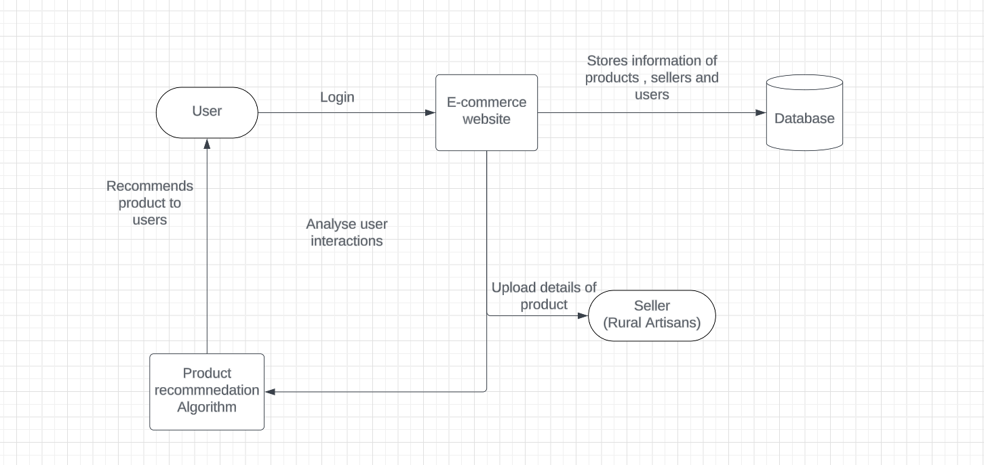

**Fig 3.1: System Architecture**

## DEVELOPMENTAL ENVIRONMENT

* + 1. **HARDWARE REQUIREMENTS**

The hardware requirements may serve as the basis for a contract for the system’s implementation. It should therefore be a complete and consistent specification of the entire system. It is generally used by software engineers as the starting point for the system design.

## Table 3.1 Hardware Requirements

|  |  |
| --- | --- |
| **COMPONENTS** | **SPECIFICATION** |
| PROCESSOR | Intel Core i5 |
| RAM | 16 GB RAM |
| GPU | NVIDIA GeForce GTX 1650 |
| MONITOR | 15” COLOR |
| HARD DISK | 512 GB |
| PROCESSOR SPEED | MINIMUM 1.1 GHz |

* + 1. **SOFTWARE REQUIREMENTS**

The software requirements document is the specifications of the system. It should include both a definition and a specification of requirements. It is a set of what the system should rather be doing than focus on how it should be done. The software requirements provide a basis for creating the software requirements specification.

**Visual Studio Code, Jupyter notebook** and **chrome** would all be required.

**CHAPTER 4**

**PROJECT DESCRIPTION**

## METHODOLODGY

## 

## The methodology for developing the AI-enabled e-commerce platform involves a systematic approach encompassing various stages. Initially, a comprehensive requirement analysis is conducted to define project objectives, target audience, and essential features. Following this, appropriate technologies and frameworks are selected based on scalability, security, and user experience considerations. System design entails architecting the platform's backend infrastructure, defining user workflows, and designing an intuitive frontend interface. Backend development involves implementing functionalities for user and product management, order processing, and database interactions, ensuring robustness and security. Frontend development focuses on responsive design, intuitive navigation, and seamless integration of features like product browsing and payment processing. Machine learning algorithms are developed and integrated for personalized product recommendations, leveraging historical user data and product attributes. Deployment involves configuring server environments and conducting final testing before launching the platform to users.

## MODULE DESCRIPTION

**4.2.1 Artisan Registration and Product Listing**

1. **User Registration**: Allow artisans to register on the website by providing necessary details such as name, contact information, and craft specialization.

2. **Product Listing**: Develop a user-friendly interface for artisans to upload product images, descriptions, prices, and other relevant details.

3. **Verification Process**: Implement a verification process to ensure the authenticity of artisan profiles and product listings, maintaining trust among users.

4. **Category Management**: Enable artisans to categorize their products effectively, making it easier for users to browse and discover traditional crafts.

**4.2.2 User Interface and Experience**

1. **User Registration and Profile Creation:** Create a seamless registration process for users to create accounts and profiles, allowing them to save preferences and track orders.

2. **Product Search and Navigation:** Design an intuitive search and navigation system, enabling users to easily find specific products based on categories, keywords, or artisan profiles.

3. **Product Detail Pages**: Develop informative and visually appealing product detail pages with high-quality images, detailed descriptions, and customer reviews to facilitate informed purchasing decisions.

4. **User Feedback Mechanism**: Implement a feedback mechanism for users to rate and review products, artisans, and overall shopping experience, fostering transparency and trust.

**4.2.3 Recommendation System Implementation**

1. **Data Collection and Preprocessing**: Collect and preprocess data from artisan profiles, product listings, user interactions, and purchase history to build a comprehensive dataset.

2. **Machine Learning Model Selection**: Choose appropriate machine learning algorithms, such as collaborative filtering or content-based filtering, for product recommendation based on user preferences and product similarities.

3. **Model Training and Evaluation**: Train the selected machine learning model using the prepared dataset and evaluate its performance based on metrics like accuracy, precision, and recall.

4. **Integration with Website**: Integrate the trained recommendation model into the website's backend infrastructure, allowing it to generate personalized product recommendations for users in real-time.

**4.2.4 Community Engagement and Support**

1. **Customer Support**: Provide multiple channels for customer support, including email support, and FAQs, to address user queries and concerns promptly.

2. **Artisan Spotlight**: Highlight featured artisans and their stories on the website, showcasing their craftsmanship and cultural heritage to create a deeper connection with users.

3. **Continuous Improvement**: Gather feedback from users and artisans to identify areas for improvement and implement iterative updates to enhance the website's functionality and user experience.

## CHAPTER 5

**RESULTS AND DISCUSSIONS**

## OUTPUT

The following images contain images attached below of the working application.

Example instance of home page

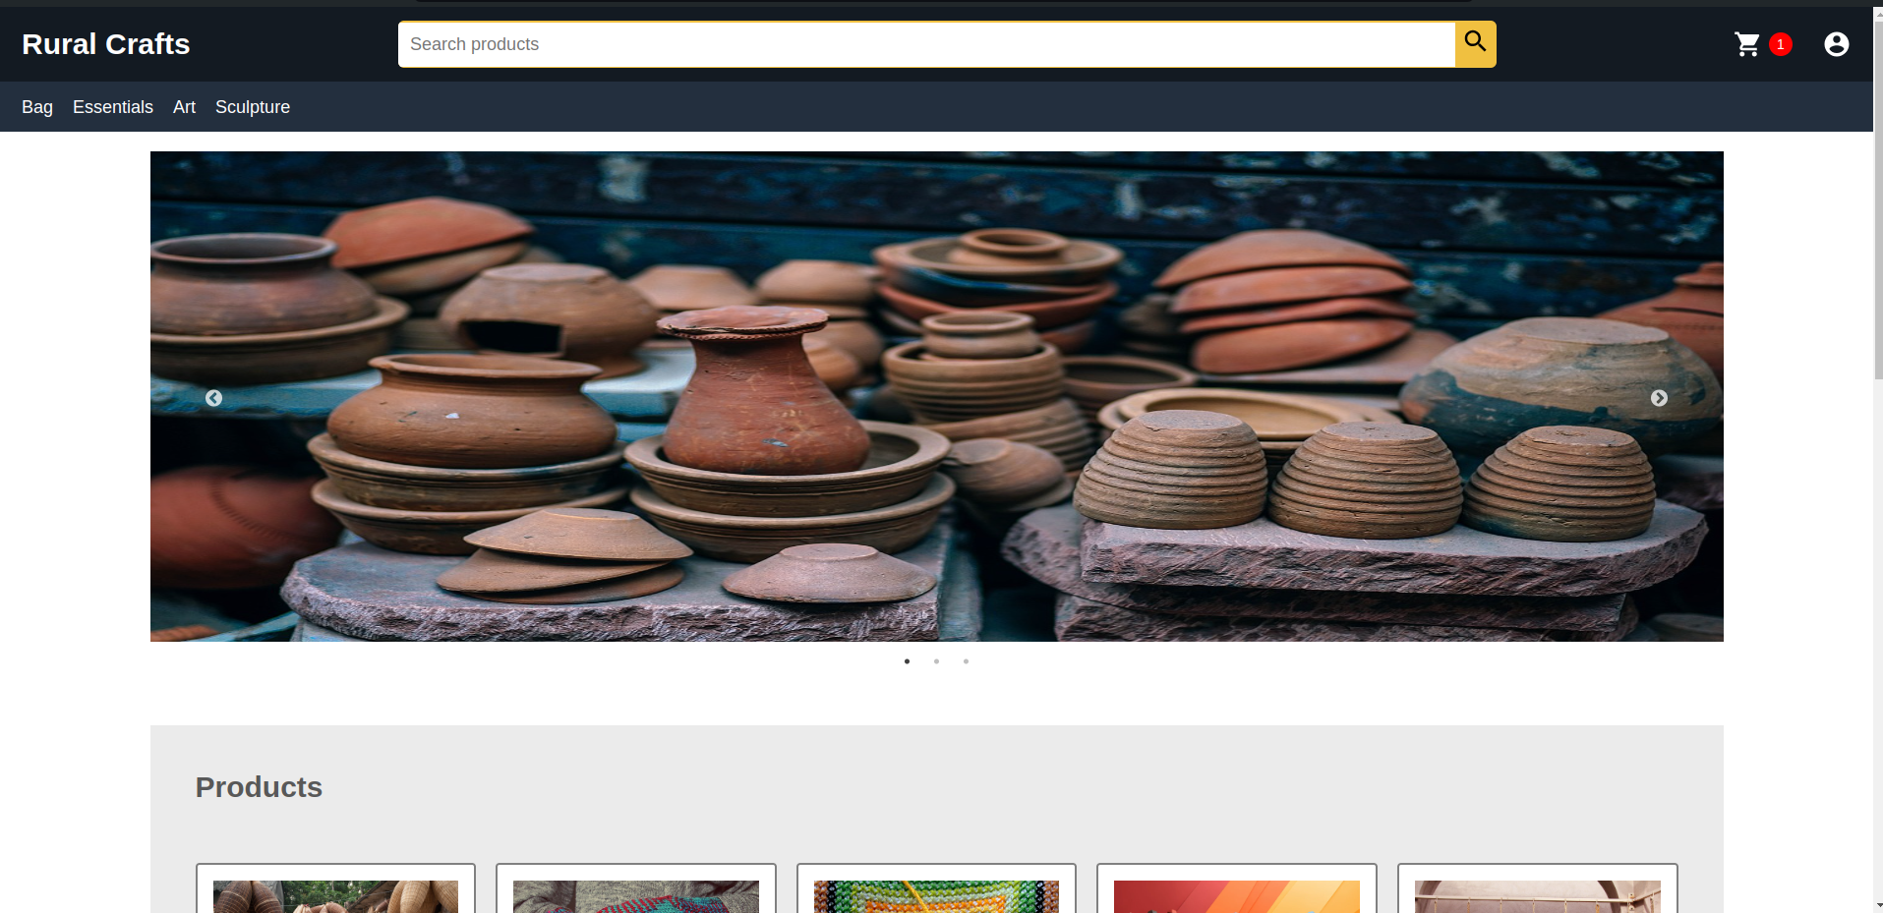

## Fig 5.1: Home Screen

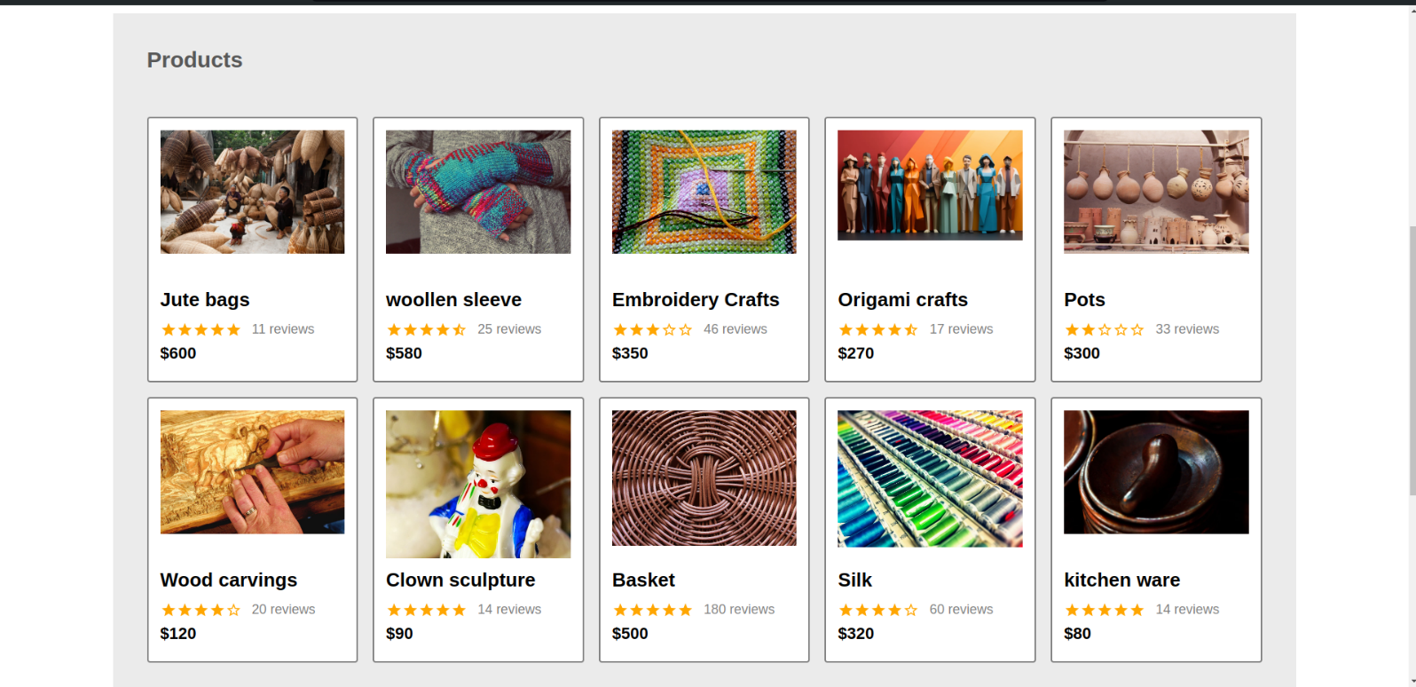

**Fig 5.2 List of Products**

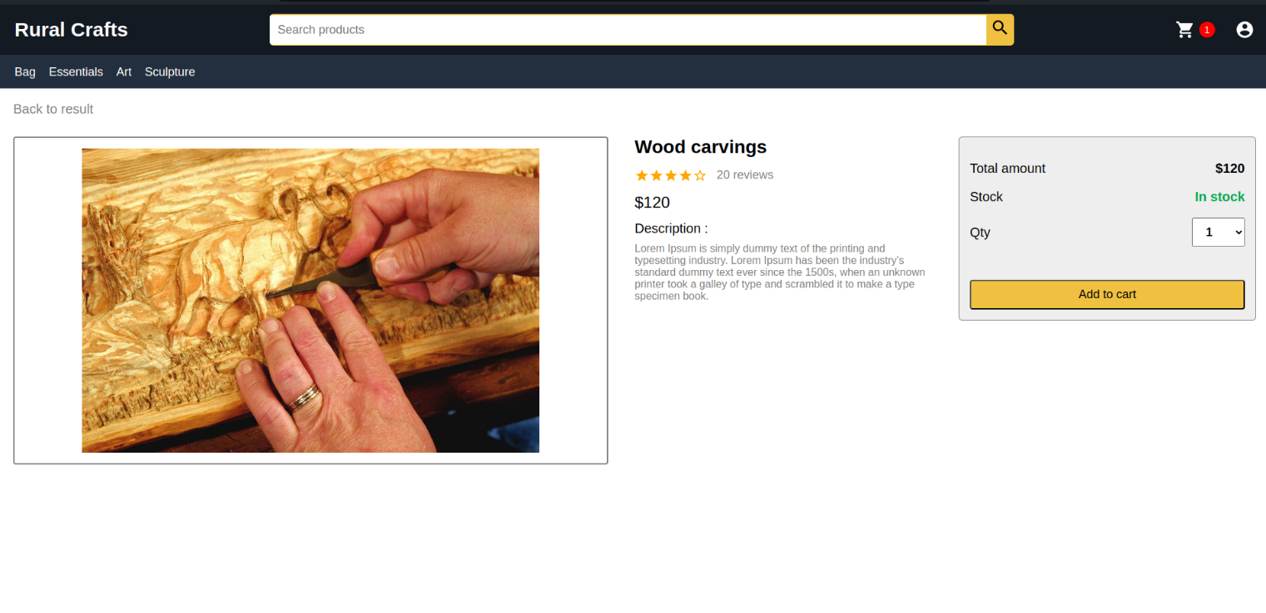

**Fig 5.3 Checkout Page**

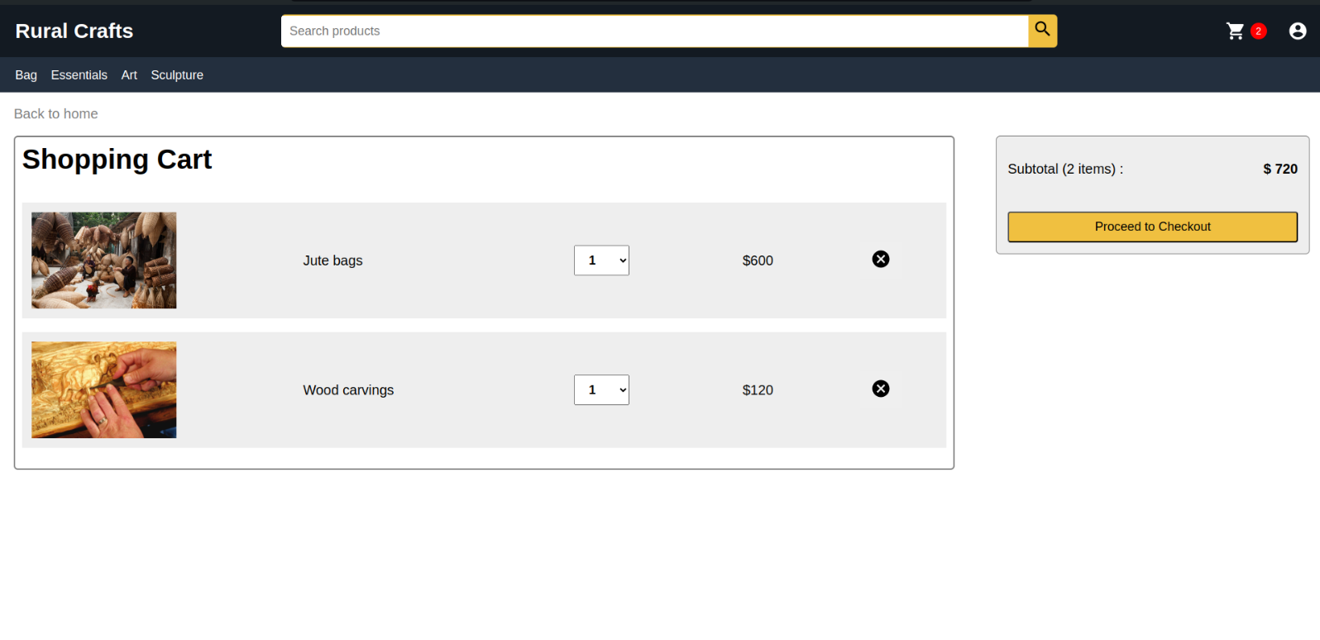

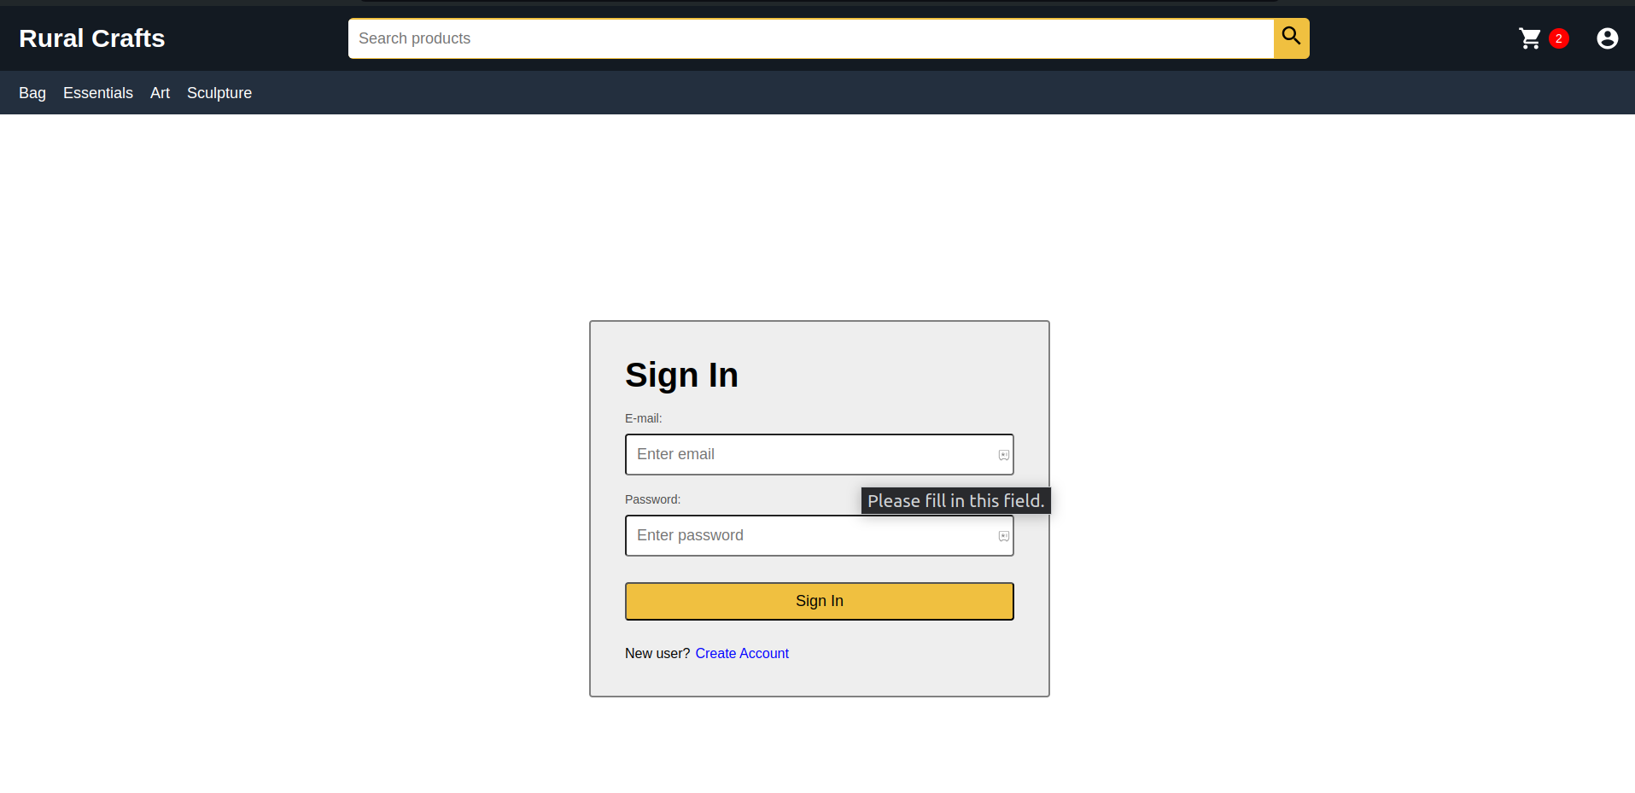**Fig 5.4 Cart**

**Fig 5.5 Login Page**

* 1. **RESULT**

The AI-enabled e-commerce platform project have been promising, showcasing significant advancements in promoting traditional products, supporting rural artisans, and preserving cultural heritage. Through the implementation of personalized product recommendations driven by machine learning algorithms, user engagement and satisfaction have markedly improved. Artisans have been empowered with a digital marketplace to showcase their crafts, leading to expanded market reach and economic empowerment. The platform's community engagement features have fostered meaningful interactions among users and artisans, creating a vibrant online community around traditional crafts and cultural heritage. Additionally, educational content has enriched user’s understanding and appreciation of traditional craftsmanship, fostering cross-cultural understanding. While the platform has demonstrated efficient and secure transaction processing, further refinement is needed to address challenges such as accessibility and scalability. Overall, the project has underscored the transformative potential of technology in preserving cultural heritage and promoting inclusive economic growth in rural communities.

## CHAPTER 6

**CONCLUSION AND FUTURE ENHANCEMENT**

## 6.1 CONCLUSION

The development of the AI-enabled e-commerce platform represents a significant milestone in the preservation and promotion of traditional crafts, support for rural artisans, and the conservation of cultural heritage. The platform's personalized product recommendations, community engagement features, and educational content have contributed to enhanced user engagement and empowerment of rural artisans. While the project has shown promising results in fostering economic sustainability and cultural exchange, ongoing refinement is necessary to address remaining challenges such as accessibility and scalability. Moving forward, continued collaboration with stakeholders and further research and development efforts will be essential to optimize the platform's functionality and effectiveness. Overall, the project highlights the transformative potential of technology in bridging cultural divides, promoting economic empowerment, and preserving the rich tapestry of cultural heritage for future generations.

## 6.2 FUTURE ENHANCEMENT

## 1. Enhanced Personalization: Implement more advanced machine learning algorithms for personalized product recommendations based on user behavior and preferences.

## 2. Augmented Reality Integration: Integrate augmented reality (AR) technology for immersive product visualization before purchase.

## 3. Blockchain Integration: Explore the use of blockchain technology for transparent and secure transactions, ensuring product authenticity and supply chain transparency.

## 4. Localization and Multilingual Support: Offer support for multiple languages and localization features to cater to diverse cultural preferences and global users.

**APPENDIX**

**SOURCE CODE:**

import express from 'express'

import mongoose from 'mongoose'

import cors from 'cors'

import userRouter from './routers/userRouter.js'

import productRouter from './routers/productRouter.js'

import dotenv from 'dotenv'

import orderRouter from './routers/orderRouter.js'

dotenv.config();

const app = express()

const port = process.env.PORT || 5000;

const connection_url = process.env.MONGO_URL;

mongoose.connect(connection_url,{

useCreateIndex: true,

useNewUrlParser: true,

useUnifiedTopology: true

})

app.use(express.json());

app.use(cors());

app.use("/api/users", userRouter);

app.use("/api/products", productRouter);

app.use("/api/orders", orderRouter);

app.get('/api/config/paypal', (req,res)=>{

res.send(process.env.PAYPAL_CLIENT_ID || 'sb');

})

app.get('/',(req,res)=>res.status(200).send('Hello Debjit here. It is Amazon clone project.'))

// Listening to server

app.listen(port,()=>console.log(`Listeningonlocalhost:${port}`))

import React, { useEffect } from 'react'

import {useDispatch, useSelector} from 'react-redux'

import { listOrderMine } from '../actions/OrderAction'

import LoadingBox from "../components/LoadingBox"

import MessageBox from "../components/MessageBox"

import "../styles/OrderHistory.css"

import InfoIcon from '@material-ui/icons/Info';

const OrderHistory = (props) => {

const dispatch = useDispatch();

const orderMineList = useSelector((state) => state.orderMineList);

const {loading,error,orders} = orderMineList;

useEffect(()=>{

dispatch(listOrderMine());

},[dispatch]);

return (

<div className="orderhistory-container">

<h1>Order History</h1>

{loading? <LoadingBox></LoadingBox>

: error? <MessageBox variant="danger">{error}</MessageBox>

:

(

<table className="table">

<thead>

<tr>

<th>ID</th>

<th>DATE</th>

<th>TOTAL</th>

<th>PAID</th>

<th>DELIVERED</th>

<th>ACTIONS</th>

</tr>

</thead>

<tbody>

{console.log(orders)}

{orders.map((order)=>(

<tr key={order._id}>

<td>{order._id}</td>

<td>{order.createdAt.substring(0,10)}</td>

<td>$ {order.totalPrice}</td>

<td>{order.isPaid?

order.paidAt.substring(0,10)

: 'No'}

</td>

<td>{order.isDelivered?

order.deliveredAt.substring(0,10)

: 'No'}

</td>

<td>

<button type="button" className="order-details-btn"

onClick={() => props.history.push(`/order/${order._id}`)}>

<InfoIcon/>

</button>

</td>

</tr>

))}

</tbody>

</table>

)

}

</div>

)

}

## REFERENCES

[1] S. Bandyopadhyay, S. Bhattacharyya, and J. Basak, Social Knowledge Management for Rural Empowerment: Bridging the Knowledge Divide Using Social Technologies. Taylor & Francis, 2020.

[2] D. Turcanu-Carutiu and R.-M. Ion, Advanced Methods and New Materials for Cultural Heritage Preservation. 2019.

[3] M. Schrage, Recommendation Engines. MIT Press, 2020.

[4] W. Zhang and Z. Wu, “E-commerce recommender system based on improved K-means commodity information management model,” Heliyon, vol. 10, no. 9, p. e29045, May 2024.

[5] P. Pavan Kumar, S. Vairachilai, S. Potluri, and S. N. Mohanty, Recommender Systems: Algorithms and Applications. CRC Press, 2021.

[6] J. O. Environmental And Public Health, “Retracted: Artificial Intelligence Technology Driven Environmental Factors Extraction and Analysis Method in Traditional Clothing Handicraft,” J. Environ. Public Health, vol. 2023, p. 9761936, Oct. 2023.

[7] P. Egana-delSol, “The impacts of a middle-school art-based program on academic achievements, creativity, and creative behaviors,” NPJ Sci Learn, vol. 8, no. 1, p. 39, Sep. 2023.

[8] J. Wei, “Research on B2C Online Marketing Mode based on Multimodel Fusion and Intelligent Big Data Analysis Method,” Comput. Intell. Neurosci., vol. 2022, p. 8868722, Jul. 2022.

[9] S. Elliot, Electronic Commerce: B2C Strategies and Models. John Wiley & Sons, 2002.

[10] L. Petersen, A business model for the digital B2C/B2B platform. The development based on an ecosystem. GRIN Verlag, 2020.

[11] R. Singh, Bottom of the Pyramid Marketing: Making, Shaping and Developing BOP Markets. Emerald Group Publishing, 2018.

[12] Gurtu and Amulya, Recent Advancements in Sustainable Entrepreneurship and Corporate Social Responsibility. IGI Global, 2020.

[13] K. Leelavathy, Problems and prospects of handicraft artisans in thanjavur district. Archers & Elevators Publishing House.

[14] I. Hill, L. Manning, and R. Frost, “Rural arts entrepreneurs’ placemaking - how ‘entrepreneurial placemaking’ explains rural creative hub evolution during COVID-19 lockdown,” Local Econ, vol. 36, no. 7–8, pp. 627–649, Nov. 2021.

[15] S. Lokuge and D. Sedera, Rural Entrepreneurship and Innovation in the Digital Era. IGI Global, 2020.

[16] G. Jiménez-Marín, A. L. Rodríguez, M. T. García, and J. G. Martín, Entrepreneurship for Rural Start-ups: Lessons and Guidance for New Venture Creation. Taylor & Francis, 2021.

[17] J. Li and K. Kim, “Kano-QFD-based analysis of the influence of user experience on the design of handicraft intangible cultural heritage apps,” Herit Sci, vol. 11, no. 1, p. 59, Mar. 2023.

[18] R. Tao and Q. Guo, “Artificial Intelligence Technology Driven Environmental Factors Extraction and Analysis Method in Traditional Clothing Handicraft,” J. Environ. Public Health, vol. 2022, p. 1883641, Oct. 2022.

[19] S. Guha, A. Mandal, and F. Kujur, "The social media marketing strategies and its implementation in promoting handicrafts products: a study with special reference to Eastern India," Journal of Research in Marketing and Entrepreneurship, ahead-of-print, pp. 1-xx, Sep. 2021. DOI:10.1108/JRME-07-2020-0097

[20] A. Shah and R. Patel, "Problems and Prospects of Rural Handicraft Artisans," CSRM Journal.